

UNIVERSITY OF UDINE

Polytechnic Department of Engineering and Architecture

The master’s degree course in Architectural

Integrated Architectural Design Studio 2

THE ARCTIC LENS
A suspended research habitat in the Lofoten Archipelago
Lofoten, Norway · approx. 68.2° N 13.5° E

Prof./Dott. Piotr Barbarewicz Student: Munkhtemuulen Tumenbayar
Prof./Dott. Alberto Sdegno

ACADEMIC YEAR 2025 / 2026

INDEX:

Architectural abstract
Introduction
Chapter I The tectonics of the web: Saraceno's spatial philosophy
1.1 From art installation to lived reality
1.2 The atmospheric envelope the material stratification
Chapter II The spatial logic of context: the Lofoten paradigm
2.1 Lightness as ethical necessity
2.2 Territorial infrastructure and access logistics
Chapter III The transit matrix: the choreography of ascent
3.1 The Vertical Glazed Ascent Core
3.2 The suspended tensile transit bridges
Chapter IV Morphological evolution and interior horizons
4.1 Spider-web biomimicry
4.2 The three levels of dwelling
Chapter V The spatial logic of the four aerodynamic voids
5.1 The pressure-relief valves and the Aeolian harps
Chapter VI Conclusion and architectural manifesto
6.1 The synthesis of reversibility
The Manifesto
List of boards and figures
Essential technical data
Bibliography
Sitography

Architectural abstract
There is a category of space that resists and repels architecture, not because the place is inhospitable to life, but because it is already, in itself, complete and perfectly accomplished. The Lofoten Archipelago, which extends between 67° and 68.5° of North latitude along the north-western edge of the Norwegian continental shelf, belongs precisely to this category. Its granite gullies rise sheer and monumentally directly from the sea. The movement and transition of its light are unrepeatable anywhere else in the inhabited world below the Arctic Circle: in summer the light never entirely dies, and in winter it is not replaced by total darkness but by an entirely different kind of luminescence, the aurora borealis, the slow, phosphorescent pulsation of a plasmatic phenomenon that spreads across the whole sky. This phenomenon denies, at the root, the conventional architectural notion of a “ceiling.” Building in the Lofoten, therefore, is not a matter of solving problems of spatial enclosure and walls. It is to enter into dialogue with powerful geological, atmospheric, optical and temporal forces that existed two billion years before the first human civilisation and that will remain for two billion years after the disappearance of the last human being.
The Arctic Lens is an architecture that earns the right to exist in this landscape by adhering to the principle of never touching the ground. It is an aerial spatial node with a zero-ground-footprint, a horizontal matrix of 32 truncated-octahedron pods suspended in the atmospheric threshold above the Lofoten fjords, at the fixed geodetic coordinates of 68.22° North latitude and 13.56° East longitude. This cloud-like settlement does not rest on any lower load-bearing pillar. It does not press upon the earth’s crust with its own mass. It is suspended in the air by a network of high-tensile-strength, locked-coil braided steel multi-point cables, Ø 85 mm in diameter, anchored to the vertical wall of the ancient Precambrian granite that defines the eastern threshold of the fjord. This cable geometry was not composed of a conventional drawing board; it was discovered through the recurring logic of tension that governs the silken architecture of the spider’s web. This idea is precise, and it is the structural foundation of the entire project. The study of the data on the web-weaving process of the artist and scientist Tomás Saraceno, his Arachnophilia series, his Cloud Cities installations and his solar-powered Aerocene aerostatic envelopes (Saraceno, 2011, 2015, 2020), is not a merely stylistic reference pasted onto the surface of this project. It is its underlying philosophy, the gestures of a temporary art, brought to the scale of a permanent and inhabited architecture, calibrated against climatic extremes.
The truncated octahedron was not chosen arbitrarily from the catalogue of Platonic and Archimedean solids. It was chosen because in 1887 Lord Kelvin defined it as the only geometric solution capable of filling three-dimensional space without leaving voids while simultaneously keeping the surface area per unit of volume at an absolute minimum (Kelvin, 1887; cf. Weaire and Phelan, 1994). It is the preferred form that nature itself employs to subdivide volume into identical cells at the least material cost. In this project that mathematical economy has become architectural economy: each pod, with an internal volume of 837.8 cubic metres, is clad in only 282.6 square metres of surface, a figure that saves as much as 34.2 per cent of material compared with a sphere of equal size. Every gram of membrane material encloses the maximum possible volume of heated Arctic air. This geometry is not ornament. It is the fundamental structural argument from which every other decision descends.
These 32 polyhedral cells form a continuous matrix extended along the horizontal axis, not stacked vertically like a tower, nor compressed laterally like a slab, but dispersed across the Lofoten sky in a form more akin to a molecular diagram than to any conventional building typology. The spatial programme distributed within this matrix is articulated into five categories of use: 8 laboratories of marine biology and Arctic climate research; 12 residential pods; 6 shared eco-terraces; 2 technical cores containing the mechanical and life-support infrastructure that makes life possible in the −20 °C cold; and 4 aerodynamic voids, deliberately deprived of the building envelope and left as pure frame structure. These 4 voids perform a crucial structural role: they lower the wind-resistance coefficient of the cluster-city, admit the Arctic zenith light directly into the interior, and transform the powerful winter storms into architectural music.
The 120 inhabitants of The Arctic Lens, the scientists, artists and environmental engineers who come to work in the most extreme and most pristine marine and atmospheric conditions on Earth, arrive by two routes. From land, they leave the E10 road that connects the Lofoten Islands and pass through an intelligent, concealed logistics terminal, carved deep into the granite mountain, entirely invisible from the surrounding landscape. From the sea, research vessels dock at a semi-submerged floating ocean pier, in the sheltered zone of the fjord, a solution that fully protects the cold-water coral ecosystem of Lophelia pertusa, which grows at depths of 80–200 m on the sea floor and is protected under Norwegian law. From these two logistics nodes the inhabitants rise through a 45-metre Vertical Glazed Ascent Core fixed to the vertical rock wall, an ascent that conveys the sensation of a journey through geological time, before crossing, on horizontal tensile transit bridges of carbon fibre and transparent ETFE membrane, a continuous and doorless interior. There, suspended above the fjord, surrounded only by the tensile geometry of the cable network and the semi-transparent skin of the pneumatic envelope, the aurora borealis becomes the living ceiling of the bedroom, and the Midnight Sun becomes a living clock, marking time by projecting the shadows of the structural steel onto the transparent floor.
This is not architecture in search of comfort. It is witnessing architecture. The Arctic Lens is designed to make its 120 inhabitants the most attentive and most precisely placed observers at the most extreme limit of the world, and it resolves all this while leaving the minimum possible material trace on nature, so that, when the building’s century of service has ended and the cables are released one by one from the anchors in the rock, the rock wall will close its own history back up and the fjord will never remember that a building was ever there.
Keywords: suspended architecture; zero-ground-footprint occupation; truncated octahedron; spider-web biomimicry; reversible tensile tectonics; ETFE pneumatic envelope; phenomenology of Arctic light; fjord ecology (Lofoten).

Introduction

This project does not arise from a crisis of form, but from a crisis of architectural attitude. In extreme territories, building has too often been imagined either as siege, in which the environment is treated as an enemy to be sealed out, or as icon, in which remoteness becomes the stage for aesthetic exceptionalism. The Arctic Lens proposes a third position: architecture as a porous discipline, capable of sustaining collective life in suspension while allowing the atmosphere, seasonality and environmental intelligence to remain active co-authors of space.
The Lofoten are not employed here as a picturesque backdrop, but as an epistemic condition. The archipelago is a place where marine biodiversity, climate observation, renewable-energy research potential and spectacular regimes of light coexist within a fragile environmental context: a territory particularly charged with meaning for a project that intends to fuse research habitat and ethical measure. In such a landscape, architecture must make itself legible as an act of calibrated presence rather than as territorial occupation. The project therefore poses a precise spatial question: how can a research settlement for 120 residents inhabit an Arctic fjord without flattening the terrain, sealing off perception or naturalising a permanent impact? The answer offered is not miniaturisation, but suspension. By lifting the settlement above the water and restraining it laterally against the cliff by means of a network of cables, the project transforms the conventional ground plane into a visual, ecological and moral distance, preserving the fjord as an observed field rather than as a consumed substrate.

Chapter I — The tectonics of the web: Saraceno’s spatial philosophy

1.1 From art installation to lived reality

There is a recurrence that our discipline recognises: a new spatial idea is first expressed in art, in a temporary, unconditioned, time-limited form, and only afterwards does that idea reveal that it contains within itself the seed of permanent and stable architecture. Buckminster Fuller’s geodesic dome became a real building only after touring the world’s universal expositions (Fuller, 1975; Calladine, 1978). Frei Otto’s studies of tensile nets on the thin skin of soap films began as a biological curiosity and became the monumental roof of the Munich Olympic Park (Otto, 1967; Otto and Rasch, 1995). Tomás Saraceno’s Cloud Cities, luminous clusters of interlocking polyhedral volumes, hung from the ceilings of museums in Hamburg, Berlin, New York and Venice (Saraceno, 2011, 2012), are today undergoing exactly this architectural transition. The Arctic Lens is the expression of that transition into lived reality.

This lineage belongs to a broader tradition of suspended spatial utopias. Constant Nieuwenhuys’s New Babylon (1959–1974) proposed the raised megastructure as a ludic and continuous territory (Constant, 1974); Yona Friedman’s Ville Spatiale imagined dwelling as a reticular infrastructure suspended above the existing ground and the existing city (Friedman, 1958–); Superstudio’s Continuous Monument pushed the grid to its limit as a neutral and potentially infinite field (Superstudio, 1969). From contemporary examples of raised and infrastructurally expressive landscapes, such as the marine-sensitive logic of Heatherwick Studio’s Little Island in New York (Heatherwick Studio, 2021), comes the awareness that support systems can be shaped to preserve light, habitat and the lived experience of being above the water rather than merely upon it. The Arctic Lens radicalises this principle by removing the conventional deck altogether and replacing it with an entirely suspended and inhabitable matrix.

Saraceno’s Cloud Cities were never purely artistic objects; they were rigorous spatial arguments. Each installation demonstrated, with the precision of an environmental physicist and the sensibility of a poet, that an immense wealth of spatial volume can be generated without the separate, conventional structures of wall, floor and ceiling, using nothing but polyhedral geometry. In the Cloud Cities the wall is simultaneously floor, envelope membrane, light filter and boundary of social relation. The geometry performs every task at once. Among all solids, the truncated octahedron maintains this metabolic quality at the highest level when it packs space seamlessly, and the secret lies in the fact that its faces are not all alike: of its 14 faces, 8 are regular hexagons (the most efficient spatial figure, discovered by the bee long before any builder) and 6 are squares (Fig. 2). This alternation of faces produces spatial thresholds and boundaries: the hexagonal faces become the primary open portals of social relation and of movement between pods, while the square faces become the connection nodes for the horizontal transit bridges. The building learns to speak two different languages at once, and its inhabitants move freely between these spaces without any instruction.

In bringing the logic of Saraceno’s installation to the scale of a permanent architecture of dwelling, The Arctic Lens adds a crucial element that the museum context never required: climate control. The Cloud Cities were suspended inside heated, climate-controlled galleries, so that the question of a life-protecting membrane never arose. But in the Lofoten, when the winter air reaches −20 °C and wind speeds reach 42 metres per second, the spatial question, “how do we protect the maximum inhabitable volume with the minimum surface of material?”, becomes a basic condition of survival. The genius of the truncated octahedron is that its answer to spatial efficiency and its answer to thermal efficiency are exactly the same: the very geometry that minimises surface area per unit of volume also minimises the surface through which heat is lost. Mathematical economy and environmental economy intersect at a single point.

The 32 pods connect directly to one another through their hexagonal faces by means of Ø 3,600 mm openings called Boolean Union portals, whose edges are reinforced with carbon-fibre-reinforced polymer (CFRP) to absorb the stresses that distribute themselves around the opening. These portals are not doors in the ordinary sense. They have neither leaf, nor frame, nor shutter. They are topological continuities, channels through which the interior of one pod flows, without any obstacle, directly into the interior of the adjacent pod. The resulting spatial condition is not a collection of isolated rooms connected by corridors, but a single continuous living field that, as one passes through the geometric cells, widens and narrows, changes direction and glows differently. Walking from a residence to a marine-biology laboratory, an inhabitant does not pass through separate rooms, but travels through a single continuous interior atmosphere of shifting luminance, acoustic echo, thermal gradient and social density.

This continuous, doorless spatial connection is a direct inheritance of Saraceno’s spatial philosophy and the project’s most radical social manifesto. For a community of 120 people living in extreme climatic isolation, a polar night 28 days long, a weather-dependent logistical supply and the psychological pressure of a beautiful but freezing landscape, this continuously connected architecture is not a luxury. It is a strategy of collective survival no less vital than thermal insulation. The Arctic Lens is designed so that no inhabitant is ever more than two pod diameters from the space of another person’s presence, and so that no inhabited volume is ever completely cut off, acoustically or visually, from the field of collective life. Geometry activates socialisation. Spatial topology is itself the social contract.

1.2 The atmospheric envelope — the material stratification
The outer skin of The Arctic Lens is not a wall. It is the building’s metabolism — its organ of exchange. To call it a wall would be to impose upon it the traditional logic of masonry, which works in compression and relies on its own mass and rigidity. This envelope operates on an entirely different principle: it is a very thin structure, internally pneumatic, thermally active and optically calibrated. It breathes; it keeps its own surface free of ice through an embedded electrical resistance; it diffuses the shifting Arctic light through a fritted (screen-printed) surface; and it attenuates glaring reflections without compromising the view outward. The system is composed of four distinct layers, each with a defined function, which produce the architectural skin of a living organism rather than the cladding of a static object:
- The outermost layer — a thin outer film of ETFE (fluoropolymer). Its surface is printed with a frit pattern of semi-transparent geometric dots that diffuse direct sunlight during the Midnight Sun, when the sun travels the entire horizon at an altitude between 5° and 30° and floods the interior with a raking, cutting reflection. The frit is not applied as uniform glazing but distributed as a gradient: denser at the equator of the pod, where the low-angle light strikes most aggressively, and dissolving to nothing towards the upper hexagonal apex. In this way the most precious and diffuse vertical light of the Arctic sky is admitted most fully into the interior. The outer skin is not only a climate regulator, but an optical instrument that selects light.
- The second layer — a sealed, pneumatic argon cavity, held at a slight positive pressure above the external atmosphere and continuously regulated. This gentle over-pressure transforms a thin film into a structural element (on the logic of the bubble-envelope, cf. Sloterdijk, 2011): it pushes the outer membrane outward and the inner membrane inward, keeping both permanently taut and preventing the film from flapping and rippling under strong wind. Because argon insulates markedly better than air, this cavity provides the building’s primary thermal insulation. With an indoor-outdoor temperature difference of up to 40 °C in winter, it is the basic condition that allows the seawater heat pumps to work steadily and without strain.
- The third layer — the primary structural skeleton: a nodal-ring spatial frame of carbon fibre (CFRP), a slender hollow tube that forms the fundamental skeleton of every pod. Upon it the tension-cable connections are fixed, and it is the clamping datum for the ETFE films. It distributes the concentrated forces coming from the cables evenly across the whole surface of the pod, with no partial concentration of stress. Carbon fibre was chosen for three reasons: it offers the strength of structural steel at a fraction of its weight; it does not corrode in the saline marine air over the building’s century of service, requiring no protective paint or maintenance; and its very low thermal conductivity ensures that the frame does not form a thermal bridge through which heat is lost.
- The innermost layer — a second, lighter ETFE film. Being in the protected interior, it is more supple than the outer film, and it holds an embedded network of fine radiant-heating wires whose task is to keep the surface permanently transparent. In the Arctic winter, frost and ice are the chief enemies of the view, so this heated inner film keeps its surface always above the dew point and eliminates ice entirely. It also distributes a gentle heat into the interior — not the hot, dry air blown by a conventional mechanical system, but the soft, directed warmth of a gently heated surface, perceived by the body as a mild solar glow even when there is no sun.
Combined, these four layers produce skin far lighter than a conventional glass-and-aluminium façade system, of greater insulating capacity, of finer optical performance and more durable in nature. The total weight of the outer skin of a single pod — outer film, argon system, carbon frame and heated inner film — is only about 850 kilograms. Cladding the same volume with a glass façade would require more than 12 tonnes. The skin of The Arctic Lens weighs less than 4 kilograms per square metre. It is an architecture that has learned to be as light as the air it contains.

Chapter II — The spatial logic of context: the Lofoten paradigm

2.1 Lightness as ethical necessity

The choice of site was not made directly on a map. It arose from the awareness that certain landscapes demand a specific architectural ethic before any programme, structure, material or form. The Lofoten Archipelago is exactly one of these places. This region lies on the edge of the European continental shelf, in a zone of permanent climatic turbulence where the warm Gulf Stream, having crossed the Atlantic carrying tropical heat, collides directly with the cold Arctic water mass arriving from the north. It produces some of the most magnificent and most violent weather phenomena on Earth. As the warm, humid marine air rises above the cold Arctic water, it condenses into dense low clouds, sea fog and sudden storm fronts, and it defines the essential quality of Lofoten light, not the direct, cutting light of the Alps or the Mediterranean, but a light filtered through a thousand atmospheric filters before reaching the eye: pearly, directional, in continuous movement. Had Monet come to the north, this is the light he would have painted.

This climatic instability is not a weakness of the site. It is the principal architectural heritage and the source of the project. The extreme winter climate of the Lofoten, south-westerly winds at 42 metres per second, temperatures dropping to −20 °C in January, and wave heights exceeding 15 metres in the Norwegian Sea (Norwegian Meteorological Institute, 2023), is the very reason why this place must become an international centre of climate research. Marine biology and Arctic climate science demand not that these phenomena be observed from afar, but that one stands in their midst. The laboratory must be inside the phenomenon, not outside it. What architecture must provide is not an artificial warm space imposed against the exterior, but a resilient threshold that transmits to the interior the phenomenological reality of the place, its acoustics, its light, its thermal drama, with precision.

This is the central argument in favour of an architecture of lightness. It is not a matter of aesthetic preference, nor the display of a new technological material; it is the only honest and truthful architectural response to this particular territory. To erect a concrete monument here would be an act of enormous architectural arrogance. It would be like saying: “this landscape is a problem I must solve, an enemy I must subdue.” A traditional heavy building, a foundation sunk into the geology of the rock, a compressive mass pressing on rock and soil, contracts towards the place a material debt that can never be repaid. It damages the ancient granite, wounds the sea floor and severs the visual continuity of a landscape that appears most magnificent precisely when there is no building upon it. And when, one day, at the withdrawal of funding, at the change of programme, or when the sea rises a few metres along the shore, the building is abandoned, it will never dissolve on the scale of geological time; it will remain as a scar of rubble.

The Arctic Lens contracts no such debt. Its suspended cable system does not resist the force of the wind, but allows the building to sway gently with it, an elasticity that concrete could never achieve, an engineering intelligence that gently absorbs the very loads that would break and collapse a stone wall. The steel cables that work in pure tension do not snap suddenly under an external influence; through their elasticity they redistribute the load gradually and give advance warning as the structural safety limit is approached. Suspended 22 metres above the surface of the fjord, the cluster-city moves as a single pendular system with its own natural period of oscillation of 8.5 seconds, tuned through the effective length of the cables, just as a spider’s web sways gently in the wind. This period is gentle enough not to be perceived by the human body as vibration, and it avoids entirely any resonance with the dominant frequencies of the site’s wind and wave motion. The building does not fight the Arctic storm. It moves with it, at its own speed, in its own rhythm.

The total material mass of The Arctic Lens, cables, frame, envelope skin, mechanical systems, interior fittings and the body weight of 120 people together, amounts to a surprisingly small fraction of the weight of an equivalent concrete building. A conventional research station discharges 1,200 tonnes of structural mass onto the ground, whereas The Arctic Lens distributes a total of 108 tonnes uniformly across 48 anchor points in the rock wall. This load is an infinitesimal force for the ancient Precambrian granite, which has borne the weight of vast glaciers for two billion years, has been compressed beneath marine sediments and has been lifted by the tectonic movement of the continent. The lightness of The Arctic Lens is not an expression of fragile weakness. It is the ultimate engineering precision, the architectural intelligence that calculates exactly how many grams of material are needed and then refuses to use a single gram more (cf. Schlaich, Bergermann and Schlaich, 2005).

2.2 Territorial infrastructure and access logistics

Architecture cannot exist without the logistical infrastructure that sustains it. A building without logistics is only a sculpture. The Arctic Lens, being a beautiful object suspended in the air above the Lofoten fjord, functions as living architecture only because it possesses two principal territorial flow nodes that connect it to the world’s scientific networks, to the supply chains and to the human community. These routes were designed with the same precision as the building itself, and their integration into the landscape follows one hundred per cent the same zero-trace ethic as the building.

The first flow connects by land. The E10, Norway’s main road axis, connecting the islands from the village of Å, at the southern tip of the Lofoten, to Fiskebøl in the north, by means of bridges and undersea tunnels, passes 3.8 kilometres from the project site. A dedicated branch leaves this road and descends as a tunnel into the depths of the granite mountain, following the natural fissures and tectonic structure of the rock itself. Following geology in this way keeps the volume of rock excavation at an absolute minimum and lets the internal geometry of the mountain do the work. The tunnel leads to an underground intelligent logistics terminal carved 15 metres below the flat summit of the rock, deep within the mountain.

The walls of this terminal are the raw Precambrian rock of the mountain itself, unclad, lit by motion-sensing LEDs, equipped with automated goods handling, a cold store for scientific samples and the mechanical infrastructure of the seawater heat pumps that supplies the building’s primary thermal energy. This terminal is completely invisible from the external landscape, concealed one hundred per cent. Its entrance portal is set flush with the rock wall, dimensioned precisely for vehicles and framed in marine-grade stainless steel of a dark grey tone that dissolves into the saline marine air, so that it cannot be distinguished from the wet granite. Anyone observing the gully from the sea has no way of knowing that people live and work inside the mountain. The architecture firmly refuses spectacle at the scale of the landscape. It is made for the people who are already there, and it is a hidden presence, invisible to those who seek it from outside.

The second flow connects by sea. The offshore research vessels, the supply nodes and the passenger craft that connect the islands to the mainland dock at a floating ocean pier placed 200 metres from the rock base, in the most sheltered coastal zone of the fjord. This pier is a semi-submersible structure whose main floating pontoons lie 5 metres below the surface of the water, above the zone of maximum wave action. The sea-floor anchor points of the pier’s synthetic-fibre mooring lines were selected by a team of marine biologists specially invited by the Norwegian Institute of Marine Research, in order to protect the cold-water Lophelia pertusa coral colonies that grow below 80 metres on the sea floor (Norwegian Institute of Marine Research, 2023). These coral reefs are extremely slow-growing, ancient, irreplaceable and strictly protected under the Norwegian Nature Diversity Act of 2009 (Naturmangfoldloven) (Miljødirektoratet, 2024). The decision to use a floating pier was taken precisely to protect them: the floating mooring lines exert no compressive pressure on the sea floor, its floating platforms cast no permanent shadow on the bottom and, should future surveys reveal a new coral zone not identified in the initial survey, the pier can be freely relocated.

From this floating pier, a fully enclosed cable-car system climbs the vertical rock wall and connects directly to the mouth of the logistics terminal inside the mountain. This cable transport works, like the upper transit bridges, on a logic of pure tension: suspended cables, devoid of any intermediate support tower, form an aerial line between the pier and the rock wall that never touches the ground. Passengers rising 40 metres along the rock in its transparent glazed gondola experience the same sensation of geological time, the wet Precambrian granite within arm’s reach, the archive of the planet’s first two billion years of tectonic history flowing past at their side, before the gondola enters the mouth of the terminal deep in the mountain and deposits the passenger in the warm, controlled, high-technology logistics space within. This arrival sequence is designed so that every inhabitant of The Arctic Lens can never forget what magnificent space they have arrived in. Geology welcomes every person’s journey.

Chapter III — The transit matrix: the choreography of ascent

3.1 The Vertical Glazed Ascent Core

The movement from the hidden logistics terminal inside the mountain to the suspended cluster-city is the most powerful and most carefully choreographed sequence of the building’s phenomenological programme. It is not merely a movement through 45 vertical metres; it is a transit journey through two billion years of geological time, from the depths of the oldest rock of the Norwegian continental shelf to the open atmosphere above the fjord, from geological compression to architectural tension, from the memory of the Earth to the present time of the sky. The design of this core obeys a single principle: the glass must never lie.

The core is a structural node of four hollow structural-steel backbone columns. This configuration gives it the stiffness needed to resist the strong lateral wind pressure that arrives along the vertical axis of the building at 45 metres’ height. This vertical backbone is not sunk into the depths of the rock. It touches the rock surface only laterally and fixes itself to it: high-tensile steel-bar anchors connect the core to the rock wall at regular intervals along the vertical axis, each drilled horizontally into the rock and sealed to the clean granite, so that the lateral wind load is transferred directly into the solid rock of the mountain without pushing down at the base of the core. The core does not rest on the ground. It leans laterally against the rock wall and bears upon pure horizontal supports, and the rock, with two billion years of compressive experience, absorbs this load into itself without a sound.

The glass wall that encloses this steel backbone is structural glass: a low-iron, ultra-transparent laminated glass that simultaneously performs the roles of lateral spatial enclosure, thermal barrier and optical film. The glass is not clamped by aluminium frames as in a conventional curtain wall. It is fixed to the steel backbone by means of transparent point connections, slender spider fittings that do not interrupt the human view, so that, as the inhabitant ascends, the entire field of vision is filled by the Precambrian granite. Within the core there is no finishing material. The raw rock, wet with the deep water of the fjord, and the character of its mineralisation, bands of grey gneiss alternating with veins of dark-grey amphibolite, and veins of quartz that glint like frozen lightning in the light of the core’s LEDs, all of this is itself the interior decoration of the building. The geology itself is architecture.

The project documents describe the phenomenology of this vertical ascent as “the journey from memory to atmosphere” (cf. Merleau-Ponty, 1962; Zumthor, 2006). In the lower third of the core, up to 15 metres above the level of the terminal, the inhabitant is still deep in the rock of the mountain, the rock wall surrounding them on three sides, the view towards the fjord through the glass just beginning to open. The quality of the air here is that of the deep air of the mountain: cool, mineral, slightly humid, and the low-frequency vibration of the building’s mechanical systems is perceived through the thickness of the rock rather than through the air. In the middle third, between 15 and 30 metres, the core separates entirely from the rock of the mountain, and the vast view of the fjord opens to the west. The first appearance of the suspended cluster-city is seen from below through the transparent glass floor of the cabin, and the cable network, capturing the Arctic light in its thousands of nodes, glitters in the sky like a silver geometry. In the upper third, between 30 and 45 metres, the core emerges fully into the open air. The force of the wind arrives together as sound and as vibration. The cluster-city arrives exactly at eye level. And as the cabin slows and the doors open, the inhabitant steps out of deep geological time onto a cantilevered steel platform, the threshold of the first bridge.

This instant, the moment of passing from the lift to the bridge, is the principal threshold experience of the project. Behind: stone, weight, compression, deep geological time. Ahead: cable, tension, atmosphere, the open Arctic sky and the living world of a floating city that sways very gently in the wind, 22 metres above the fjord.

3.2 The suspended tensile transit bridges

The transit bridges, which connect the lift platform to the building cluster and join the pods to one another horizontally, are the most distinctly Saracenian elements of The Arctic Lens, the node at which the tensile geometry of the spider’s web is translated into real architecture. They are not ordinary corridors. They rest on no frame sub-structure. They do not touch the ground. They are suspended in pure tension between the structural nodes of the cluster-city’s cable network, and their form is defined by the catenary geometry of their own weight and by the lateral wind pressure acting on the outer skin.

Each bridge is composed of three interconnected structural systems. The first is a pair of high-tensile locked-coil cables running parallel along the lower edge of the bridge, the same cables as the building’s main network, so that the bridges integrate directly into the city’s pre-compression geometry, without any special hardware. The second is a circular carbon-fibre skeleton: a ring backbone about 2.4 metres across, assembled from twelve arched segments, which gives the bridge its tubular section and spreads the tension of the outer skin evenly around its perimeter. The third is the outer envelope that completely encloses the bridge: a two-layer ETFE skin with the same embedded heating as the pods, clamped to the carbon rings so that the tube stays warm and free of cold bridges.

The resulting structure is visually extraordinary and structurally entirely clear. The inhabitant walking along a transit bridge is inside a transparent ETFE tube; underfoot, the floor is a walkway of transparent laminated glass suspended by stainless-steel tie-rods inside the CFRP ring, so that the surface of the fjord sea is directly visible 22 metres below. Walls and ceiling are completely transparent. The Arctic sky is always overhead. As one crosses the bridge, the entire image of the city opens fully, the other pods, the cable network, the bare frame of the four wind-relief voids, the rock wall, the fjord and the distant horizon. The transit movement along a bridge is not a mere functional pause between two points. It is the moment at which the building declares its spatial ambition to the highest degree: the inhabitant is simultaneously inside the architecture and in the very heart of the dissolved landscape, with no visual separation between them. The transparent ETFE membrane provides thermal and acoustic protection while visually dissolving almost to nothing. The Arctic Lens does not frame the view. It is the view.

These bridges vary from 18 to 42 metres in length depending on the distance between pods. The longest spans, the bridges that cross the positions of the four wind-relief voids, are the most demanding from a structural point of view and the most powerful from a phenomenological one. Walking along a transparent 42-metre bridge stretched above an open void, the inhabitant who looks straight down through the glass floor sees, beneath them, the bare hexagonal ring frame of an empty, membrane-less pod, and beyond it the open sea of the fjord. From the floor of the bridge to the surface of the sea there is no architectural element to block the view. It is the point at which architecture comes as close as possible to the open space of nature, an interior that is warm and protected, yet whose floor is completely transparent and whose field of vision is one hundred per cent open in every direction to the horizon.

The bridges maintain their structural equilibrium through the interaction of the main cables, the stiffness of the CFRP ring frame and the pre-compression of the membrane. They rely on no ground support. The entire bridge system is in a state of continuous pure tension throughout its service life, the cables pulling from both sides, the membrane compressing the ring inward, and the ring maintaining its form through its circumferential compression, which is the only compressive force in the bridge structure. Just as the orb-weaver’s web, whose radial threads carry the primary tension load while the spiral threads maintain the geometry during the prey’s movement, the structural hierarchy of the bridge is entirely clear, honest, and expresses the highest refinement of architecture: the intelligence of obtaining the maximum result with the minimum means.

Chapter IV — Morphological evolution and interior horizons

4.1 Spider-web biomimicry

The structural network of The Arctic Lens was not born of abstract engineering calculation. It was born of the living observation of nature. Tomás Saraceno’s Arachnophilia research, his work, together with a team of arachnologists, physicists and materials scientists, of digitising the three-dimensional geometry of the web and the distribution of forces in the collaborative webs of multiple spider species, became the principal structural source of this project: it demonstrated that a spider’s web is an isotropic load-sharing system that distributes force with great efficiency within its outwardly chaotic and asymmetrical organisation. When a thread of a spider’s web breaks, through an external impact or through the weight of the morning dew, the pre-compression that thread carried is not lost. It is redistributed, very rapidly and automatically, to the neighbouring threads, preventing the entire web from collapsing. The web protects its own structure gradually (graceful degradation). Against sudden failure, it preserves partial function by redistributing the load. It is a highly statically indeterminate system, with an enormous number of redundant load paths, so that the failure of a single path does not compromise the integrity of the whole.

This principle of a pre-compressed and redundant network is the structural philosophy of the cable network of The Arctic Lens. The primary suspension network consists of high-tensile locked-coil cables that connect the structural nodes of the 32 pods to 48 anchor plates on the rock wall, supported by a network of lighter secondary cables that join adjacent pods horizontally (Fig.3 ). The entire network forms some 1,200 metres of cable line, whose geometry is tuned so that, even under the most severe combination of wind, self-weight and the weight of the inhabitants and their work, no cable ever loses its state of tension. A cable in compression is a cable that has lost its elasticity, a destabilised cable. A cable in tension, however small the load it carries, contributes to the integrity of the entire structure. The project makes the maintenance of every member in tension the fundamental condition of structural honesty.

The weight the building carries can be told as a simple architectural story. The permanent weight of the 32 pods, the carbon-fibre frames, the membrane envelope, the cable network and the mechanical and life-support systems, together with the weight of life itself, the 120 inhabitants and all their equipment and supplies, comes to only about 108 tonnes: the whole suspended city, entrusted to the rock. Snow, too, is answered by form rather than by mass: the gently pressurised ETFE cushions and the winter heating keep the outer membrane above freezing, so that snow melts and slips away, and because the inclined faces of the truncated octahedron are steep it is shed under its own weight. The building is not made heavier to resist these forces; it is shaped so that they pass gently through it.

The anchor plates that transfer the cable forces into the rock wall are the elements that express the project’s zero-trace ethic most precisely. Each plate, a compact square of marine-grade stainless steel that resists corrosion in the saline, foggy environment of the Lofoten, is fixed by a high-tensile steel-bar anchor set into a hole drilled into the rock and sealed with cementitious grout. The crucial word in this assembly is grouted: the grout that fixes the anchor in the rock is entirely durable over the building’s century of service, yet in a future planned dismantling it can be mechanically removed without damaging the structure of the rock itself.

When The Arctic Lens completes its service life, when the scientific programme it has served moves elsewhere, or requires a different spatial form, the anchor bar is released and cut flush with the plate. The anchor holes are filled with grout flush with the rock surface. The stainless-steel plates are unscrewed and completely removed. The trace left in the granite is then only 48 small, plugged holes, which, through the biological regeneration of the lichens and mosses that grow at that elevation of the Lofoten rock, will become indistinguishable from the surrounding raw rock. A future generation coming here to build anew would find clean rock. It would never find rubble, rusted reinforcement, or the archaeological scar of a building that passed this way without knowing its nature.

4.2 The three levels of dwelling

Within each inhabited pod, the vertical axis of the truncated octahedron becomes the project’s most intimate field of spatial organisation. The geometry forms a vertical span of 24 metres from the lowest point of the hexagonal floor to the highest apex of the hexagonal ceiling, the height of a substantial building, held in a single continuous volume. In The Arctic Lens this vertical axis is divided into four distinct atmospheric strata, each of which produces a different rhythm of human life (Fig. 4-5) and a different mode of relation with the Arctic exterior.

Level +0.00 m: The Life-Support Stratum. The base of the pod, where the geometry narrows towards the lower hexagonal mouth. These are the mechanical viscera of the building: here are the seawater heat-pump units, whose heat-exchange pipes descend from the mechanical interface of each pod along the cable network to a depth of 15 metres below the surface of the sea, into the zone where the water temperature is stably +4 °C / +6 °C all year round; the greywater collection and recycling system, which filters the community’s wastewater through a biological filter to prepare the irrigation water for the plant terraces above; and the electrical distribution boards, fire-suppression systems and compressor lines that maintain the pressure of the ETFE membrane. The spatial quality is not a vast open volume, but a deliberately protected and warm environment, a low, sheltering base beneath the scientific floor above. The glued-laminated timber ceiling softens the sound-vibration of the mechanical compressors into what the designers call the “heartbeat” of the pod: a low, subdued hum. The acoustics of this stratum matter: the continuous low-frequency vibration induced in the cable network by the wind (the lower Aeolian spectrum, between 8 and 20 Hz) is perceived here most physically. Standing beside the mechanical mass, the inhabitant feels in their own body how the building breathes, like a living creature, in the wind.

Level +8.00 m: The Active Scientific Domain. The working heart of the pod. Here the climate-controlled hydro-gardens and aquaponics grow the community’s own food in the Arctic winter, and the specialised laboratory workstations, the wet lab for environmental sampling, the dry lab and its server core, carry out the science for which the whole settlement exists. This stratum is the reason The Arctic Lens is not merely a shelter but an instrument: a place where marine biology and climate research are conducted from inside the phenomenon they study, the fjord and the Atlantic pressing directly against the ETFE membrane beside the workbench. The living green of the hydro-gardens and the precise light of the laboratory share one continuous volume, so that food, science and daylight are never separated into different rooms.

Level +16.00 m: The Equatorial Social Core and Living Quarters. The middle of the pod, where the truncated octahedron reaches its widest cross-section, producing an open space of 10,800 mm internal diameter. It is the Equatorial Social Core, the field in which Saraceno’s spatial philosophy is most fully expressed. The floor is a laminate of transparent glass and timber, and its perimeter is bound not by walls, but by the surface of the ETFE membrane that inclines from the equatorial line upward, towards the apex. This membrane is at once the thermal skin of the building, its structural envelope, its Arctic window and its social boundary. The Ø 3,600 mm Boolean Union portals cut into the hexagonal faces of the equatorial zone form the highest-order spatial connections, aligning exactly with the portals of the adjacent pods, so that the life of one pod flows directly into the next, and the current of collective life runs freely without any door, gate or corridor. Around this open social core are the private living quarters and shared lounges, so that domestic life and communal life are always within sight and sound of one another. There are no insulating corridor and no threshold between dwelling and gathering. The building, in its spatial philosophy, firmly refuses these separations.

Along the perimeter of this equatorial stratum, where the outer membrane begins to curve upward, the project provides small eco-terraces: narrow bands of expanded-clay-aggregate soil 150 mm deep, irrigated by the recycled greywater rising from the base, in which Arctic cold-resistant plants grow, moss, reeds, dwarf polar willow and polar herbaceous plants capable of growing in the diffuse light of the Midnight Sun, with the heated membrane keeping them at a climatically normal temperature. These terraces are not merely decoration. They are the biological commons of the building: a living surface that absorbs carbon dioxide, regulates the internal sound and reminds the inhabitants each day that life can continue even in the Arctic cold, and that nature is not only harsh but also fertile.

Level +24.00 m: The Celestial Sanctuary. At the crown of the pod, beneath the highest hexagonal face, is the Celestial Sanctuary, the upper sleeping platform. It is the most intimate point of the pod, the most optically charged and the most phenomenologically concentrated. The upper hexagonal face of the truncated octahedron, with an edge length of 4.2 metres and an internal circular clear span of about 7.3 metres, is built, like the rest of the building, with the ETFE system, but with one enormous difference: no frit pattern is printed on its outer film. It is one hundred per cent completely transparent. The argon cavity and the heated inner film function normally, but both films are optically clear, admitting the entire solar spectrum, from near ultraviolet to far infrared. The upper hexagonal panel is, in the most literal sense, a gigantic lens, a flat transparent window 7.3 metres in diameter that shows the Arctic sky directly, without any optical distortion.

In summer, an inhabitant lying on the raised bed of this Celestial Sanctuary experiences the Midnight Sun with a spatial intensity that no conventional architecture on the ground could ever offer. As the sun travels its entire orbit at 5°–20° above the horizon, it continuously rotates the linear shadows of the pod’s upper structural frame and of the cable network (the shadow of the CFRP ring backbone seen through the transparent film) across the interior like the hand of a clock, drawing a sundial on walls and floor without any mechanical clock. The floor of the Celestial Sanctuary is the most precise sundial of the building, and the person lying there lies at the very centre of the mechanism of time.

In winter, the Celestial Sanctuary becomes a space without precedent in the history of architecture, impossible to describe with ordinary building language. On about 200 of the year’s nights, the aurora borealis appears here as a vivid and dominant phenomenon that covers the entire sky. Curtains of green and pink plasma kilometres high, flowing along the lines of the Earth’s magnetic field, ionise the oxygen and nitrogen atoms of the upper atmosphere 100–300 kilometres above the planet and generate a luminous current, and this light enters the room directly through the transparent ETFE zenith window without any filter, any dissolution, any chromatic distortion and any structural obstacle. The aurora borealis is, in the most literal sense, the living ceiling of the bedroom. Lying on their bed at the very crown of the pod, the inhabitant, through the transparent argon-filled ETFE lens directly overhead, looks upward, penetrating the Earth’s atmosphere, directly into the light of the cosmos. The building was designed to give a human being exactly this moment. Every thermal calculation, every structural detail, every material choice and logistical decision of The Arctic Lens was ultimately made to serve this single instant of human life: the gift of a warm and protected human presence, suspended safely above the Lofoten fjord, witnessing with its own body how the very sky of the planet glows and sways overhead.

In this sense, summer and winter here are not merely external seasons; they are internal conditions. In summer, the diffuse, prolonged light dilates time, softens the sleep cycles and flattens the distinction between morning and evening. In winter, the darkness condenses social life, intensifies the internal glow and amplifies the meaning of the framed celestial events. The architecture does not aspire to a perfect seasonal neutrality; it lets the inhabitant feel the passage of the year in nuanced ways. A true Arctic architecture cannot merely survive the environment; it must teach its inhabitants how to inhabit changing time.

Chapter V — The spatial logic of the four aerodynamic voids

5.1 The pressure-relief valves and the Aeolian harps

In the course of designing a building, the architect must resolve the boundary between the question of what the building contains and the question of what the building is. The Arctic Lens resolves this question through four aerodynamic voids, four deliberately and permanently left empty within the matrix of the 32 pods. No membrane envelope. No floor. No internal programme. No inhabitant. Only the bare geometry of the truncated octahedron’s structural frame, CFRP frame members that draw in space the edge network of the 14-faced polyhedra, whose hexagonal and square faces are one hundred per cent open to the sky, the wind, the rain and the Arctic cold. Locked in their position by the cable network, they contribute to the structural and spatial life of the city not through what they contain, but through what they let pass through themselves.

To understand the structural role of these voids, one must calculate what happens when an immense solid mass, a chaotic cluster of buildings with a large frontal cross-section, is placed in the path of the powerful Arctic wind. The wind does not merely push a building and pass on. It flows around the mass of the building, separates at the leading edges and forms a turbulent low-pressure wake behind it; the difference between the front and rear pressures is the principal cause of the lateral force that drives a building forward. If all 32 pods were closed with full membrane, the wind arriving at 42 metres per second would meet the city as a solid wall, building an immense zone of stagnant pressure across its whole face, a vast horizontal thrust that would arrive, undiminished, at the anchor plates in the rock through the cables.

The four aerodynamic voids resolve this problem not by making the structure heavier and more robust, but by changing the very logic of the building’s relation to the wind. When the building is itself porous, 4 of the 32 positions being open frame, so that the wind flow can pass freely through the building rather than around it, two important physical phenomena occur simultaneously: the size of the high-pressure zone on the front of the building is drastically reduced, because a certain portion of the incoming airflow passes straight through the empty pods rather than dispersing laterally; and the turbulent wake behind the building is re-pressurised by the airflow emerging through the empty channels, balancing the pressure. The net result is that the wind-resistance of the cluster-city drops sharply. These four empty pods reduce the lateral wind load by as much as 38.2 per cent without adding a single kilogram of material to the building. They save an enormous structural force by generating absence.

This structural efficiency in reducing force acts directly on the cable system. The reduction of cable tension lowers the load requirement of the anchor plates in the rock, reduces the engineering intervention on the rock wall and therefore further reduces the “zero-trace” ecological footprint. The mathematics of the wind and the ethic of leaving no trace arrive here, simultaneously, at one and the same answer. The building’s responsibility towards nature and its structural intelligence are the same thing expressed in two different languages.

But the aerodynamic voids do not have only an engineering function. They act as vertical light wells that diffuse sunlight into the interior in a remarkable way. The horizontal dimensions of the city (48 × 62 metres) and the locked three-dimensional structure of the 32 pods tend to limit the penetration of light into the innermost zones, deep within the city; and if the city were entirely enclosed, the inner pods would receive only a weak, diffuse light passed in from outside. In the limited daylight hours of the Arctic winter, the illumination of the central zone of a full city would be uniform, dry and devoid of any living spatial drama, like the interior of a deep-plan London office on an overcast day. The four empty pods, placed strategically on the windward side, on the two lateral wings and at the geometric centre of the city, become real channels through which light enters directly. The zenith light from the sky enters through these open frames without any membrane filter, any ETFE dissolution and any alteration by the argon cavity. It arrives with the same raw quality with which it strikes the rock wall and the surface of the sea: raw, directional, of extreme chromatic precision, carrying directly into the interior the polarised, low-contrast blue tone of the high-latitude winter light. As this light passes through the empty frames and strikes the equatorial layers of the lower and adjacent pods, it produces sharp, crisp-edged shadows, chiaroscuro, the linear shadows of the void’s CFRP backbone and of the secondary cables drawing fine geometric lines on the interior walls of the neighbouring pods. The contrast of light and shadow thus produced is not the uniform, dull illumination of a modern workplace. It is a union of deep, dark shadow and sharp, brilliant points of light as in a Caravaggio painting, which transforms the space into a living drama of geometry and atmosphere, whose colour shifts continuously with the flow of the day and the season, and which always makes the inhabitants feel in which part of the city, and at which hour of the Arctic sky, they are.

These four voids are, finally, Aeolian harps (wind harps), the instruments through which the Arctic storm enters the building as music. As the winter storm passes through the open frame of an empty pod, it strikes the carbon frame and the network of slender carbon tie-rods that hold the spatial faces. These tie-rods are there for a structural reason, to redistribute the forces that the absent membrane would have carried, but they were also tuned, in consultation with acoustic engineers, so that the wind curling around them sets them singing. The tone they produce lies in the lowest register of human perception, a force felt directly by the body as physical vibration rather than heard by the ear as sound. During a winter storm the four empty pods generate a continuous deep tone, which crosses the cable network and the frames of the adjacent pods and becomes an acoustic presence felt bodily in the surrounding laboratory and residential layers, the very voice of the wind, transformed by the geometry of the building into a current that flows between music and meditation.

The Arctic Lens does not seal the storm outside to silence it. It listens to it. And through these four voids it also teaches its own inhabitants to listen to the voice of nature.

Chapter VI — Conclusion and architectural manifesto

6.1 The synthesis of reversibility

Architecture has dedicated a great part of its own history to the pursuit of permanence. From the moment the first stone was laid upon another with the intent to outlast a human life, the deepest ambition of our discipline has been durability, the capacity to survive as a cultural artefact even after the civilisation that produced it has transformed or disappeared entirely. We have built in stone to resist time. We have poured concrete, because concrete is, by the measure of materials science, one of the most durable substances that human industry can produce in great quantity. We have sunk foundations deep into the earth, because depth equalled stability, stability meant permanence, and permanence was understood as the expression of cultural seriousness.

The Arctic Lens directly refutes this equation. It does so not from any nihilism, not from the conviction that permanence is intrinsically wrong, but from a finer and higher ethical position: that in a fragile landscape, permanence is itself an aggression against nature. To build permanently in the Lofoten, to pour concrete into the geology of the rock, to sink foundations into the bed of the fjord, to force a heavy compressive mass onto a landscape defined by the tensile dynamics of wind, wave and tide, is to declare that the ambition of the building matters more than the integrity of nature. It is to say: “my right to be here is worth more than the existence of the Lofoten coral reefs, of the migratory Arctic terns, of the two-billion-year-old granite, of the marine plankton community that feeds the richest fishing zone in the world.” This is, in the traditional Greek term, hybris, the excess of the individual human will against the cosmic order of nature, the arrogance of architecture.

Against all this, The Arctic Lens advances an entirely different measure of architectural ambition. The maturity of a civilisation is not measured by the weight of the monument it erects. It is measured by the precision of its departures, by how cleanly and completely it knows how to leave a place when its work is done, by how free of scars it knows how to leave that space. The greatest ambition of The Arctic Lens is not its structural innovation, its thermal efficiency, or the scientific discoveries that will be made there over the course of a century. Its greatest ambition is the complete erasure of its own trace. To erect in the air a scientific centre of real, high quality and international relevance, and a space of collective life for 120 people, and, when the time comes, to remove it from nature without any residue: this is the highest and only legitimate result that the architectural discipline can win from such a landscape.

The reversibility of the project is not a fine word pasted after the fact onto a project made for other reasons. It was the primary condition of the project, which governed every material choice, every structural detail, every method of assembly. The cable connections are mechanically reversible joints, because they can be unwound again. The anchor bars are sealed with grout into the rock holes, because the grout, unlike poured concrete, can be mechanically removed without damaging the structure of the rock itself. The carbon-fibre frame members are bolted to their nodes, because bolts can be unscrewed. The ETFE membranes are clamped to their frames, because the clamps can be released, the film rolled up and placed in containers, and the frame broken down segment by segment into a flatpack ready for transport. The building is, in the most technical sense, a kit of parts, an elastic system locked together by tension, pre-compression and the intelligent composition of geometry, and capable, when the time comes, of being dismantled one piece at a time in the exact reverse order of its assembly sequence.

When the service life of The Arctic Lens ends, the dismantling will proceed in the following order. The ETFE membranes are released from their clamps and rolled up. The CFRP frame segments are unscrewed and lowered gently, with the help of the cables, onto the floating pier below. The secondary cables between the pods are released from their nodes and wound up for reuse. The main suspension cables are released in a specified sequence, the windward anchors last, to hold the city steady until the final phase, their tension slackened and released from the anchor plates. The anchor plates are unscrewed from the steel bars. The bars are released and extracted from the rock holes. The holes are filled with cementitious grout, levelled flush with the rock surface. The mechanical infrastructure of the underground logistics terminal is completely removed, and the tunnel mouths are sealed with natural-stone panels matched exactly to the colour and texture of that rock. The mooring lines of the floating pier are released, and it is towed away to its next task.

In the vertical rock wall, there remain 48 plugged holes, invisible from afar, and, within just ten years, as lichens and mosses begin to cover their surface, indistinguishable from the raw rock. Nothing remains in the water of the fjord. The underground terminal at the summit of the mountain is completely sealed and filled. In the airspace above the fjord, the air in which the cluster-city was suspended at 22 metres’ height, nothing remains. The morning mist passes freely through that space as it did before the first cable was stretched. The Arctic terns reclaim the thermal columns above the surface of the sea. The Lophelia corals on the sea floor, kept safe, without a single moment of pressure, throughout the building’s century of history, continue their extremely slow growth cycle (only 3–5 millimetres a year) for another thousand years, in the cold, dark, nutrient-rich water of the Lofoten fjord.

Architecture must, ultimately, free itself from dependence on the erection of monuments. A monument says: “I was here, and this is the proof of it.” But to leave material proof is not the highest aspiration of architecture. To be a witness to nature is its highest value. The Arctic Lens says: “I was here; I paid the most vigilant attention to everything that was here before me, the geology, the flows of the wind, the biology, the transitions of light; I strove to make something worthy of the attention the place demanded; and when my work was done, I left it one hundred per cent clean, exactly as I had found it.”

This is an architecture that has become an ethical act. Building in a world that is not ours to possess, that is not human property, is to say precisely this. And precisely because The Arctic Lens also refuses the temptation of spectacle, refusing to transform the fragility of the site into scenery for its own image, its formal intensity is to be read as discipline rather than as exhibition: its beauty is a consequence of coherence, not of arbitrary visual extravagance.

This is not a mere summary. It is the central architectural manifesto that this building has striven to express in space, from the first geometric concept to the last engineering detail.

The Manifesto

Architecture must earn its own right to exist. This right is not won by the size of the building, by spectacle, by the weight of cultural reference or by the heavy carbon mass of the material, but by the precision with which one knows how to respond to the adjacent forces of geology, atmosphere, society and ecology. Every place has its own logic. Every site has its own intelligence. The first duty of the architect is to discover the intelligence of the place itself before imposing anything else upon it.

The ground is not a given upon which a building must necessarily rest. For ten thousand years architecture organised itself along the line of the earth’s surface, because that surface offered the most reliable compressive support. Today this logic has changed. High-tensile-strength steel cables, carbon-fibre frames, the high technology of rock anchoring and the spatial geometry of mathematical topology have entirely removed the requirement to relate rigidly to the ground. Architecture can now freely choose where to stand, or where to suspend itself. The Arctic Lens has chosen to suspend itself. It suspends itself in the air, because in a landscape that forbids heavy compressive mass, the engineering logic of tension is the most honest and truthful solution.

Lightness is an ethical position. Every unit of material left unused in a building is an ecological debt not inflicted on the earth. The measure of structural ambition is not the total weight of material employed, but the precision with which one knows how to draw the maximum spatial and environmental performance from the minimum material. The cable network, the CFRP frame and the ETFE envelope of The Arctic Lens resolve 5,289 square metres of heated inhabitable space with a structural mass as much as 13.6 times lower than that of an equivalent conventional concrete building. This ratio is not boasting. It is a new standard. Architecture must strive to achieve this ratio everywhere, not because lightness is fashionable, but because our planet does not have the material capacity to sustain the unlimited mass of heavy buildings that humanity erects.

The building’s skin is an active organ of metabolism, not a static wall. A building that has not thought thermodynamically about its own outer skin has not yet understood what a building is. The skin of a living organism is always active, reactive and self-regulating, and while it separates its own interior from the exterior it is in continuous exchange with the atmosphere. The ETFE pneumatic envelope of The Arctic Lens, its screen-printed outer film, its argon cavity, its embedded heating grid, possesses all these qualities at once. Simply enclosing a space is not enough. The enclosure itself must continuously think about the energy it retains.

Absence, the void, is the highest material of the project. The four aerodynamic voids of The Arctic Lens perform a structural, acoustic and luminous role greater than that of any inhabited pod of the city. That the building is more robust, lighter, more alive and more precisely tuned to its own site resides in what it has deliberately left unbuilt. Architecture has always feared the void. It must learn to use it.

Community and structure are an inseparable whole. The 120 inhabitants of The Arctic Lens are not people who arrived by chance into the structural logic of the building. The loads they impose, their movement, their emission of heat and their psychological need to perceive their fellow beings in a harsh isolation were all fundamental structural inputs that shaped the geometry and the programmatic distribution of the cluster-city. Architecture has always been, in its depth, social engineering. The only question is whether social logic is made spatially explicit or left hidden. The Arctic Lens makes it explicit.

Beauty is structural honesty made visible to the eye. The Arctic Lens hides none of its own structural connections behind ornament. The cable joints are visible. The nodal rings of the carbon frame stand out clearly at the apex of every pod. The ETFE membrane shows directly to the eye the argon cavity and the carbon skeleton behind it. The building exposes the engineering logic of its own functioning, hiding nothing and with pride, because every detail is exactly where it must be, exactly of the size it must have, and this, in its raw quality, is beautiful.

Reversibility is the true measure of a civilisation’s maturity. A civilisation that does not know how to take back what it built, without leaving a scar on nature, has not yet understood its own relationship with the planet. The building’s century of service life is not a limitation. It is a responsibility, the promise to be present one hundred per cent for an entire century, and, when the time comes, to become one hundred per cent absent. Architecture must learn this. The ambition of the monument to resist time is mere human vanity. The more difficult but noble ambition is to serve time, to offer exactly what a place needs, exactly when it needs it, and to withdraw gently when the time comes.

Architecture must learn to listen. The powerful Arctic wind that shakes the cables of The Arctic Lens is not an obstacle. It is information. The aurora that illuminates the Celestial Sanctuary is not a mere beautiful view. It is a lesson in spatial scale, a reminder that the natural phenomena architecture frames are far greater, far more ancient and far more powerful than any building humanity erects. A building that has learned, through its geology, its flows of wind, its biology and its transitions of light, to listen to what its place says, always produces wiser and more beautiful architecture than the building that imposes its own monologue on the landscape. The Arctic Lens is designed to listen. Its cables are its ears. Its voids are its voice. Its transparent apex is its eye. And the surface of the fjord sea, left perfectly clean and intact beneath the suspended city, is its architectural conscience, its clear and upright integrity.

List of boards and figures

The figures cited in the text correspond to the project’s graphic works (submission boards in 90 × 90 cm format). The board scales are territorial masterplan 1:1500 (Board 01); structural anchoring and cable geometry 1:750 and structural elevation 1:300 (Board 02); Section A–A′ and pod plans 1:80 (Board 03). The works marked as to be produced complete the iconographic apparatus in the final layout phase.

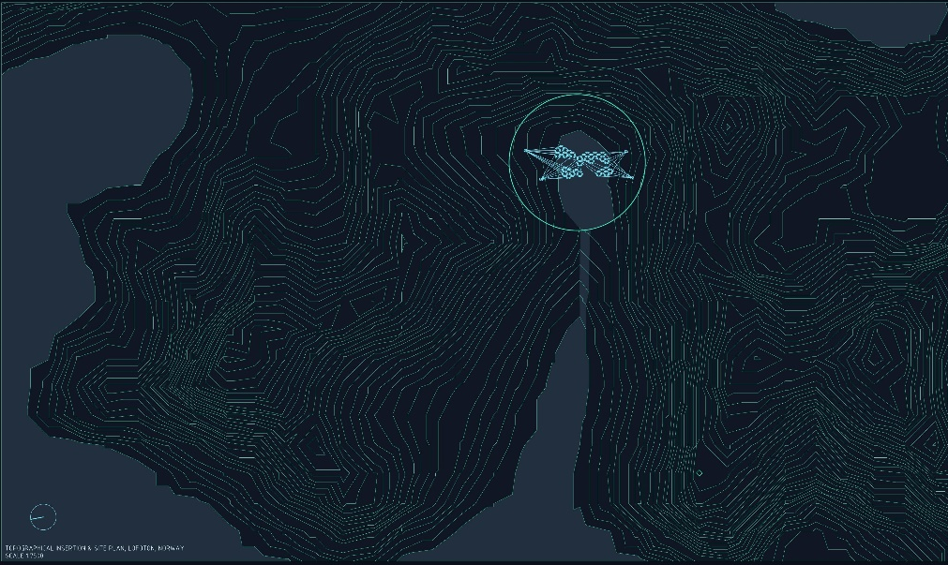
Fig. 1, Territorial insertion and perspective view of the suspended settlement in the fjord (Board 01 · Modular territorial system).

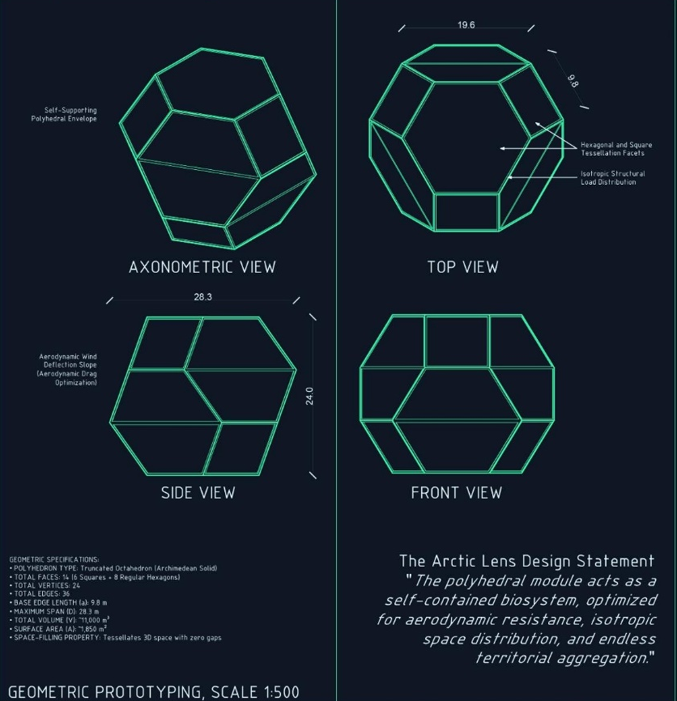
Fig. 2, Geometry of the unit: the truncated octahedron and the aggregation logic unit → field (Board 01 / Board 02).

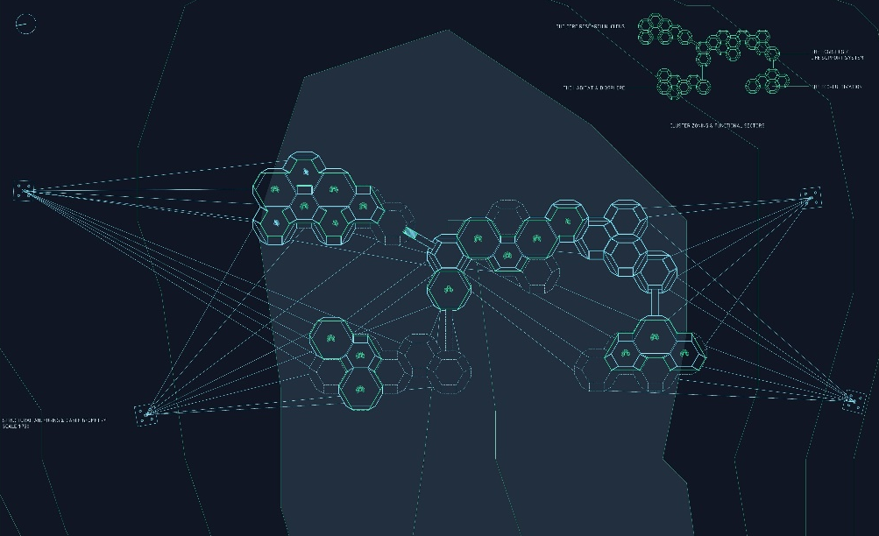
Fig. 3, Anchorage geometry and cable network (Board 02 · System and structure, 1:750); structural elevation of the cluster (Board 02).

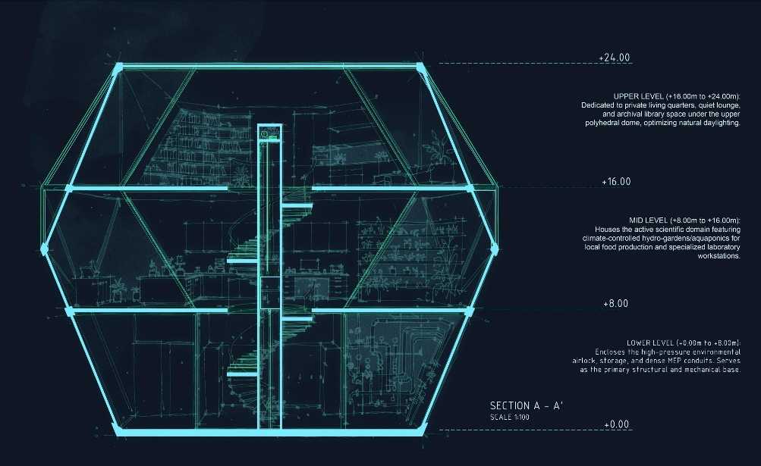
Fig. 4, Section A–A′ of the pod and glazed ascent core (Board 03 · Dwelling).

Fig. 5, The three levels of dwelling: plans +0.00 / +8.00 / +16.00 m (Board 03).
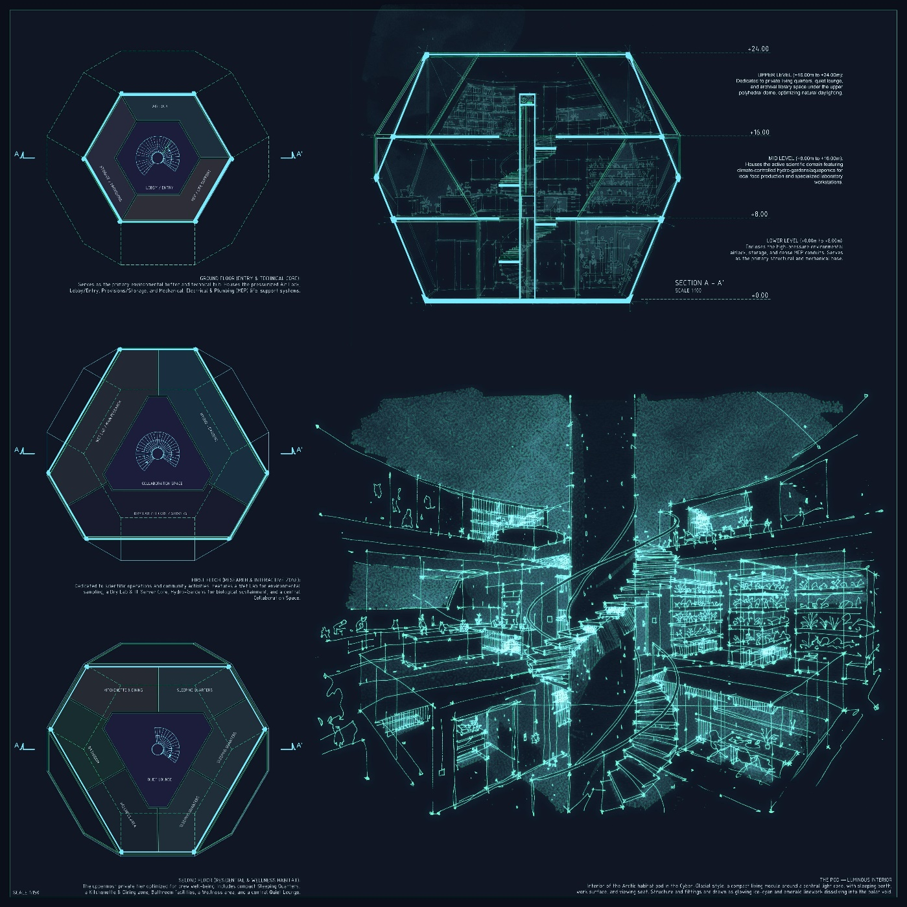
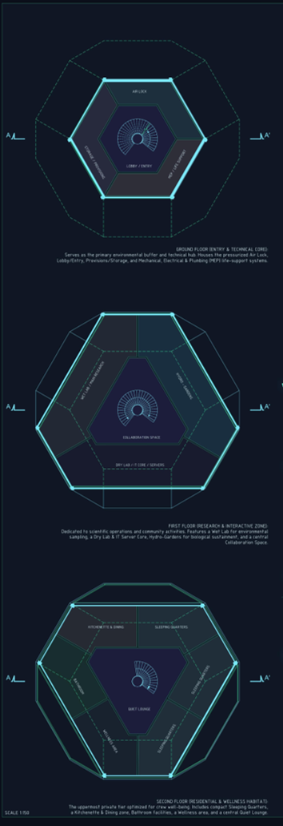

Essential technical data

Geometry, programme and settlement
Parameter | Value
Residents | 120
Cells (pods) | 32 truncated octahedra
Programme | 8 marine and climate laboratories · 12 residential pods · 6 eco-terraces · 2 technical cores · 4 aerodynamic voids
Pod diameter (internal equatorial) | 10,800 mm (Ø geometric 12 m)
Edge length | 4.2 m
Pod volume / surface | 837.8 m³ / 282.6 m² (34.2 % material saving compared with the sphere)
Union portals | Ø 3,600 mm Boolean Union, CFRP (carbon-fibre reinforced polymer)
Levels per pod | 4 strata (+0.00 / +8.00 / +16.00 / +24.00 m); internal height 24 m
City footprint | 48 × 62 m
Suspension elevation | +22 m above the fjord
Heated inhabitable area | 5,289 m² (13.6× less structural mass than equivalent concrete)
Coordinates | 68.22° N, 13.56° E — Lofoten Archipelago, Norway

Structure, envelope and performance
Parameter | Value
Natural period of oscillation | 8.5 s
Total suspended mass | ~108 t (63 t permanent + ~32 t imposed) over 48 anchor points
Cable network | High-tensile locked-coil primary cables + lighter secondary cables; ~1,200 m total
Rock anchors | 48 marine-grade stainless-steel plates · high-tensile steel-bar anchors, grouted
Envelope | 4-layer ETFE system, ~850 kg/pod, < 4 kg/m² · high thermal performance
Glazed ascent core | 45 m · structural-steel backbone · low-iron laminated glass
Transit bridges | spans 18–42 m · carbon-fibre ring ~2.4 m across · high-tensile cables
Design wind speed | 42 m/s (−38.2 % lateral load through the four aerodynamic voids)
Operating temperature | −20 °C external (winter) to internal comfort; skin ΔT up to 40 °C

Bibliography
- Calladine, C.R. (1978). ‘Buckminster Fuller’s “tensegrity” structures and Clerk Maxwell’s rules for the construction of stiff frames.’ International Journal of Solids and Structures, 14(2), pp. 161–172.
- Constant Nieuwenhuys (1974). New Babylon. The Hague: Haags Gemeentemuseum. [The raised megastructure as a ludic and continuous territory.]
- Friedman, Y. (1958–). La Ville Spatiale (The Spatial City). [Dwelling as a reticular infrastructure suspended above the existing ground and city.]
- Fuller, R.B. (1975). Synergetics: Explorations in the Geometry of Thinking. New York: Macmillan.
- Giedion, S. (1941). Space, Time and Architecture: The Growth of a New Tradition. Cambridge, MA: Harvard University Press.
- Heatherwick Studio (2021). Little Island, New York. [Raised marine-sensitive landscape; support systems shaped to preserve light and habitat.]
- Kelvin, Lord (William Thomson) (1887). ‘On the Division of Space with Minimum Partitional Area.’ Philosophical Magazine, 24(151), pp. 503–514.
- Merleau-Ponty, M. (1962). Phenomenology of Perception. Trans. C. Smith. London: Routledge & Kegan Paul. [Orig.: Phénoménologie de la perception, 1945, Paris: Gallimard.]
- Norwegian Institute of Marine Research (2023). Status of Cold-Water Coral Reefs in Norwegian Waters: Lophelia pertusa Distribution and Depth Profiles. Bergen: Havforskningsinstituttet.
- Norwegian Meteorological Institute (2023). Climate Normals for the Lofoten Archipelago 1991–2020: Station Svolvær/Helle, 68.22°N 13.56°E. Oslo: Meteorologisk institutt.
- Otto, F. and Rasch, B. (1995). Finding Form: Towards an Architecture of the Minimal. Stuttgart: Axel Menges.
- Otto, F. (ed.) (1967). Tensile Structures: Design, Structure and Calculation of Buildings of Cables, Nets and Membranes. Cambridge, MA: MIT Press.
- Saraceno, T. (2011). Cloud Cities. Exhibition catalogue. Berlin: Hamburger Bahnhof — Museum für Gegenwart. Berlin: Nationalgalerie / SMB.
- Saraceno, T. (2012). On the Roof: Cloud City. Exhibition catalogue. New York: The Metropolitan Museum of Art.
- Saraceno, T. (2015). Aerocene. Exhibition catalogue. Paris: Centre Georges Pompidou.
- Saraceno, T. (2020). Particular Matter(s). Exhibition catalogue. Linz: Lentos Kunstmuseum; Berlin: Studio Tomás Saraceno.
- Schlaich, J., Bergermann, R. and Schlaich, M. (2005). ‘Lightweight Structures.’ Structural Engineering International, 15(4), pp. 224–228.
- Sloterdijk, P. (2011). Bubbles: Spheres Volume I: Microspherology. Trans. W. Hoban. Los Angeles: Semiotext(e). [Orig.: Sphären I: Blasen, 1998, Frankfurt: Suhrkamp.]
- Superstudio (1969). Il Monumento Continuo (The Continuous Monument). [The grid as a neutral and potentially infinite field.]
- Weaire, D. and Phelan, R. (1994). ‘A Counter-Example to Kelvin’s Conjecture on Minimal Surfaces.’ Philosophical Magazine Letters, 69(2), pp. 107–110.
- Zumthor, P. (2006). Atmospheres: Architectural Environments — Surrounding Objects. Basel: Birkhäuser.

Sitography
- Aerocene Foundation (2026). Aerocene — Tomás Saraceno’s Solar-Powered Aerosolar Sculptures and Environmental Ethics Platform. https://aerocene.org
- Frei Otto Archive, University of Stuttgart — ILEK (2024). Frei Otto: Works, Projects and Research Papers 1952–2010. https://www.ilek.uni-stuttgart.de/forschung/frei-otto-archiv
- Kartverket — Norwegian Mapping Authority (2025). Topographic Data, Coastal Charts and Digital Elevation Models: Lofoten Archipelago, Nordland County. https://www.kartverket.no/en
- Miljødirektoratet — Norwegian Environment Agency (2024). Naturmangfoldloven (Nature Diversity Act, 2009) — Regulations for the protection of marine species and habitats, incl. Lophelia pertusa. https://www.miljodirektoratet.no/naturmangfoldloven
- Norwegian Meteorological Institute (2025). eKlima — Historical Climate Data Portal: Wind, Temperature and Precipitation Records for Lofoten, 1900–2025. https://www.met.no/en/free-meteorological-data
- Studio Tomás Saraceno (2026). Projects Archive: Arachnophilia, Cloud Cities, Aerocene, On Air, Particular Matter(s). https://studiotomassaraceno.org

